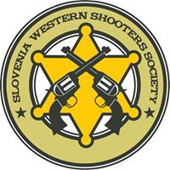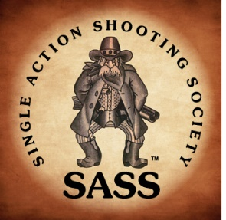

INVITATION To:
5th „Day of Anger“
INTERNATIONAL OPEN MATCH OF COWBOY ACTION SHOOTING
28. June - 30. June 2019
Kunsperk Shooting Range: Bistrica ob Sotli / Slovenia
*****************************************************************
For Mr. / Ms.:
Address:
*****************************************************************
Necessary Weapons and Ammunition:
Single Action Cartridge Revolvers, Caliber 32 or larger
Lever Action and/or Slide Action Rifle, Caliber 32 or Larger
Side by Side or Slide Action or Lever Actions Shotguns, Caliber 10-20 gauge
Sufficient amount of ammunition in relevant calibers, with lead bullets only

Contact: Denis Pirc Phone: +38 640 663 33
aka Bonnie the Caveman Mail: denis@dp-sistemi.com

