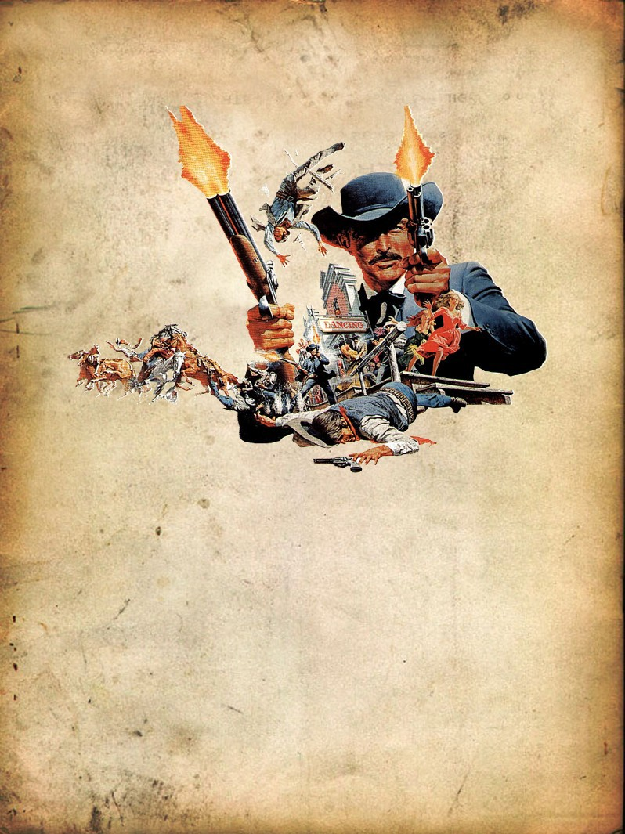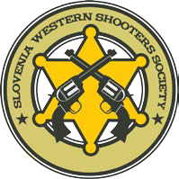*5th DAY OF ANGER*
8 Stages COWBOY-ACTION-SHOOTING-MATCH
-2019-

FRIDAY 28. And SATURDAY June 29. 2019, WILL BE AT THE SHOOTING CENTER KRAMER, KUNŠPERK 19, 3256 BISTRICA OB SOTLI, SLOVENIA,
ENTRY FEE € 35.00 / Young Guns € 15.00
Sidematch € 5.00
Registration - Deadline 16.06.2019 by www.TomProx.de
PROGRAM - Additional

WESTERN LINE DANCING
WESTERN MERCANTILE
“Bernie Blackbeaver”

DENIS PIRC TOM PROX
Range Master Match Director
+ 386 40 663 336 + 49 177 4014572

PROGRAMS

Friday: June 28, 2019
16:00 – 20:00 Shooters Registration
ca. 17:00 Sidematch: 2-3 Stages Plainsman

Saturday: June 29, 2019
07:00 – 08:30 Shooters Registration
08:30 Match Briefing
09:00 Main match 4 Stages
12:00 – 13:00 Lunch
13:00 – 16:00 Main match 4 Stages
ab 17:00 DINNER, LINE DANCE

Sunday: June 30, 2019
09:00 Clay Pigeon Shooting (if interested)

Information about prices

Overnight per person at the motel: | 15,00€
Camping per day caravan or tent with electricity: | 5,00€
Breakfast (Saturday or Sunday): | 6,50€
Cowboy Dinner Friday: | 8,50€
Saturday lunch snack: | 3,50€
Saturday dinner: | 9,00€

Registration only www.TomProx.de

Best Regards and Happy Trails
Bonnie the Caveman and Tom Prox

